**Current Process Document**

**{Automate Quantity mismatches (EDI)}**

**Version 1.0**

**Document History**

|  |  |  |  |  |  |
| --- | --- | --- | --- | --- | --- |
| **Version** | **Release Date** | **Created By** | **Description of**  **Change** | **Genpact**  **Approval by** | **Customer**  **Approval by** |
| 1.0 |  |  |  |  |  |
|  |  |  |  |  |  |

**Terminology & Abbreviations used**

|  |  |
| --- | --- |
| Vendor / Supplier | Party who sells goods / provides services to **customer name** |
| AD |  |
| Goods | Products being provided drinks, food, non-food items |
| Store | The place of delivery of good by the vendor/Supplier |
| T-code | Transaction code in SAP |
| SAP | Business ERP |
| SAP R1P | SAP Module used for maintaining master data in Europe region |
| Maxi R | Tool used by the stores to upload details of Goods received |

**TABLE OF CONTENT**

1 Introduction 4

2 Overview 4

2.1 High Level Manual Process Description 4

2.2 Target Applications 4

2.3 Process Prerequisites 5

2.4 Definitions 5

3 Process Diagram - 5

4 Mismatch management EDI Process Description 6

5 Scheduling of Activities 15

6 User rights and access 15

# Introduction

This document provides a detailed and step by step understanding of ‘Mismatch management of the EDI invoices’. These invoices are submitted by the vendors/suppliers that are on EDI to the Delhaize on a daily basis. The Delhaize team validates the invoices for accuracy of data (Quantity, Item, Price, etc) and posts the invoices for further processing. In case of any mismatches the team validates the mismatch and raise the question with the concerned team (Store or Supplier).

There are a few points to consider:

1. The vendor sends the invoices on Panteion that are on EDI process
2. The system automatically moves the invoices details to SAP and does the initial validation
3. There are seven resources in the team that manage the EDI invoices
4. Each member has been allocated a set of vendors to process and keep track of
5. The daily average volume is approximately 300+ invoices to process
6. Identification of mismatch by comparison of data from Invoice, SAP, and Maxi R is rule based. However, the query details to be sent out to team is analytical / decision based activity and is kept out of scope of the RPA automation

# Overview

## High Level Manual Process Description

1. Open the Serivices.Com site
2. Retrieve all
3. Post the items that do not have any mismatch and price mismatches
4. For the remaining items identify the type of mismatch (Quantity or Items)
5. Obtain the details of the invoice and open the invoice in Panteon and Maxi R
6. Identify the source of mismatch and raise the query with the respective team (Store or Vendor)

## Target Applications

The following applications / systems are necessary to have access to, in order to perform mismatch management of EDI invoices:

1. Microsoft Outlook
2. Microsoft Excel
3. SAP R1P – SAP Retail Production EUROPE
4. Shared drive
5. Maxi R – Desktop application

## Process Prerequisites

1. Access to SAP transaction codes
2. Access to Microsoft applications – Excel and Outlook
3. Access to Maxi R

## Definitions

1. **Vendor**

The ‘vendor’ is a party who is responsible for providing goods and services to the buyer. In this document, vendor refers to the businesses / service providers in the market who provide goods, utilities and other services to Delhaize.

# Process Diagram -

Below is the high level process flow showing step by step movement of account creation request in the system

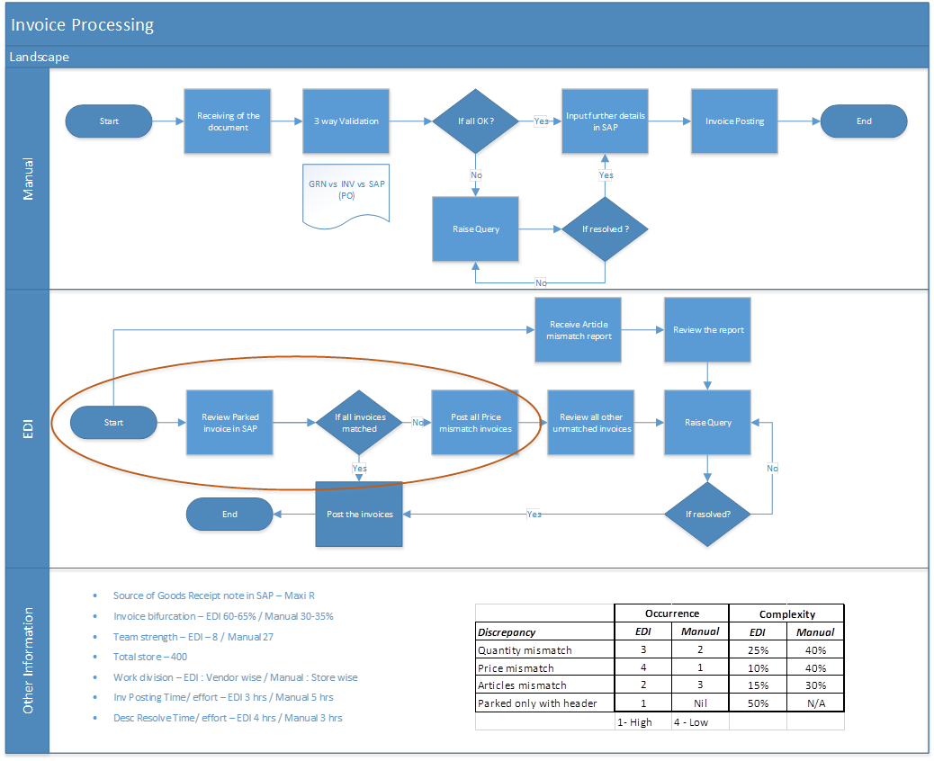

** Note: the area highlighted above is part of the SAP automation planned by the AD IT team and is still under discussion

# Mismatch management EDI Process Description

Steps required to be followed for mismatch management of the EDI invoices in the systems – SAP:

1. Login to SAP by clicking the following SAP icon on the desktop
   * Click on the SAP icon on user desktop

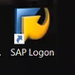

* + Select **R1P module** from the window that is being generated:

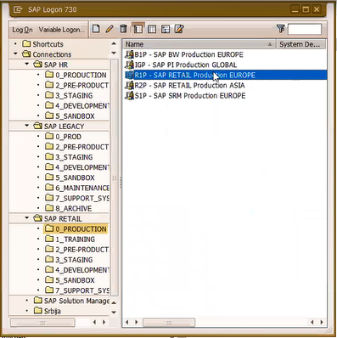

1. Open SAP Tcode – To “Display list of EDI documents” and retrieve invoices submitted by the vendor

Fig. 2.1 – “Display list of EDI documents”: initial screen

1. Determine the fields which are required to be filled to run the open invoice report

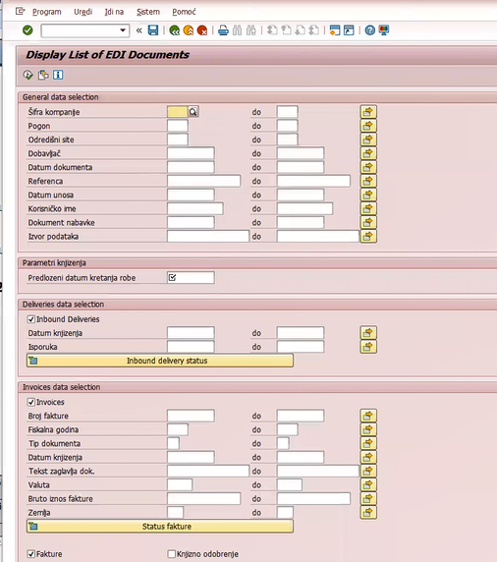

Fig. 3.1 – “Display list of EDI documents”: initial screen

1. Update the required information in SAP
   * “Supplier Number”
   * “Entry Date”
   * “Posting Date”

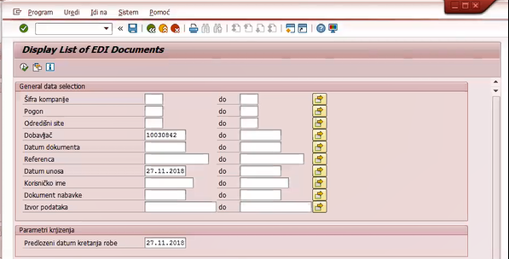

Click here

Fig. 4.1 – “Display list of EDI documents”: initial screen

1. SAP will display this list of “Parked invoices” for the searched supplier and dates as given in step 4. Click on the “Apply Filter” icon to apply filters.

Price mismatch

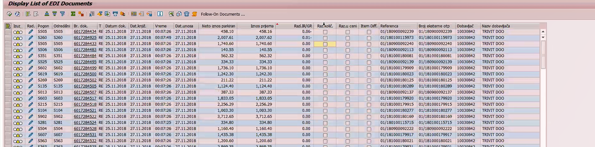

Item mismatch

Quantity mismatch

Fig. 5.1 – “Display list of EDI documents”: result screen post execution

1. Click on the icon as shown below on the apply filters screen

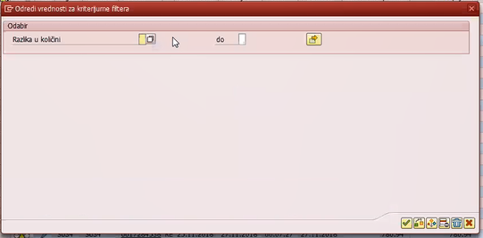

Click here

Fig. 6.1 – “Odabr”: initial screen

1. Double click on the “x”

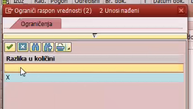

Click here

Fig. 7.1 – “Ograicenja”: initial screen: This will apply filters to filter out any blanks

1. Ensure the filter is applied as shown in the below screen and click on the tick mark below or press “enter” to apply the filters

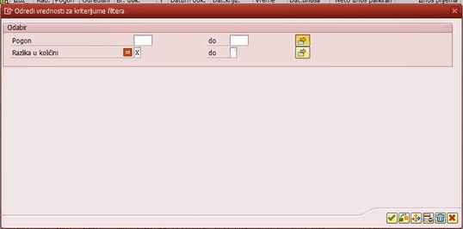

Click here

Fig. 8.1 – “Odabir”: initial screen showing the details of the filters. With this all the mismatches will be executed

1. Click on the icon to “Select all” or press “F5” to select all the list of items that are ready for posting

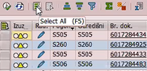

Fig. 9.1 – “Display list of EDI documents results screen”

1. Click on “execute” to post the invoices for further steps

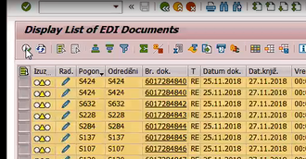

Fig. 10.1 – “Display list of EDI documents”: results screen, this step will take time (~30 min) to process/post the lines

** Note: The Posting of matching Invoices is part of the SAP Automation the IT team of AD has planned and still in discussion

1. Open another session of SAP and repeat the steps 4 & 5
2. Apply filter as shown below and click on the “tick” mark or press “enter”

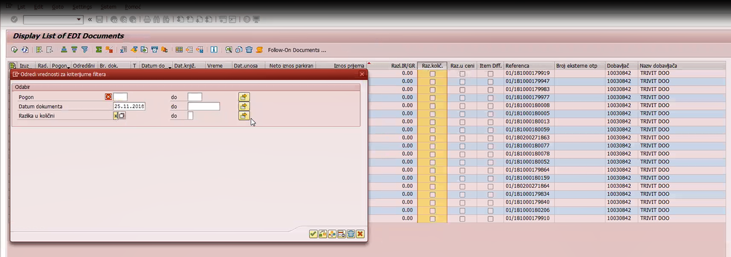

Fig. 12.1 – “Display list of EDI documents”: Filter screen

1. SAP will display only the items that have quantity mismatch as shown below with Quality mismatch with “check box”

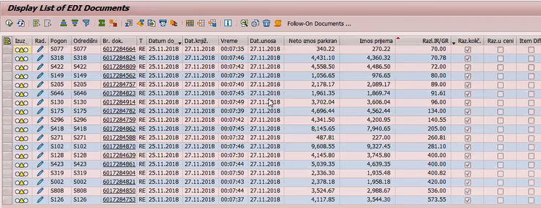

Fig. 13.1 – “Display list of EDI documents results screen”

1. Click on the  icon to edit the line item as shown below

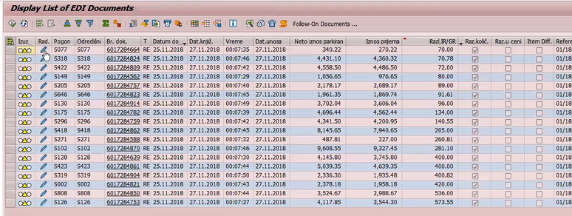

Click here

Fig. 14.1 – “Display list of EDI documents results screen”

1. SAP will display the details of the particular line item as shown below

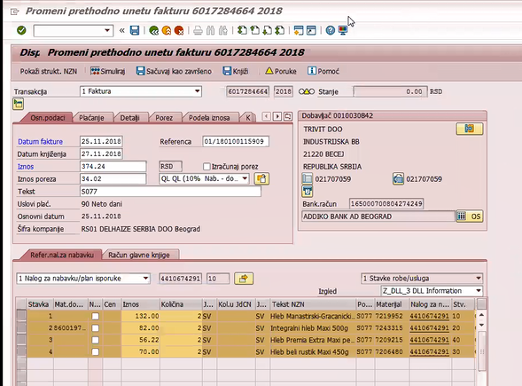

Store number in Maxi R

Fig. 15.1 – “Item details SAP screen”.. Show the details of the invoice with store details and products

1. Launch the Maxi R application



Fig. 16.1 – “Maxi R”.. Initialization screen”

1. Enter the credentials and press “enter”

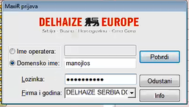

Fig. 17.1 – “Maxi R” login screen

1. Maxi R window will open as shown below

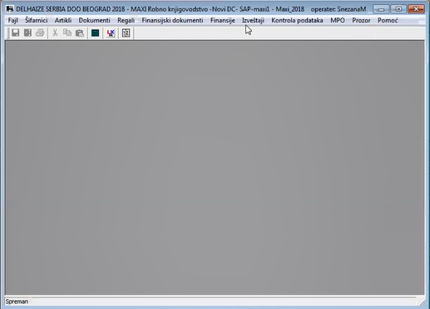

Fig. 18.1 – Maxi R initial screen

1. Click on “Izvestaji” tab and select “Pregledi dokumenata” to open all the documents available

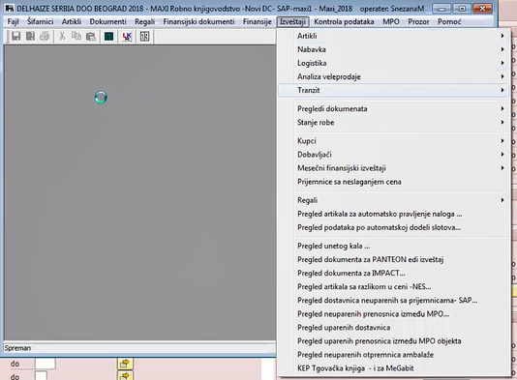

Fig. 18.1 – Maxi R initial screen

1. The application will open with the below window: Enter the search dates accordingly and the vendor details and press “enter” to display the list of documents available

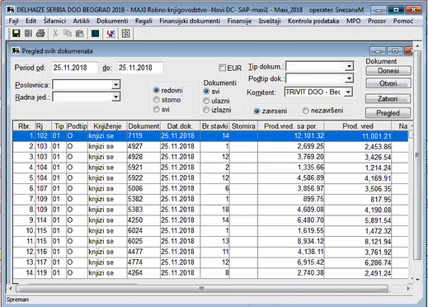

Fig. 20.1 – Maxi R search result screen

1. Click on tab to enter the store number



Fig. 20.1 – Maxi R search tool bar

1. Enter the store number extracted from step 15 and press “Enter”

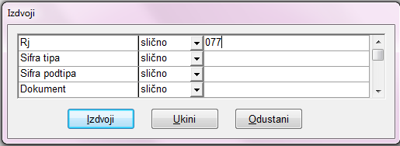

Fig. 22.1 – Maxi R filter criteria screen

1. The Maxi R will display the results only for the store mentioned

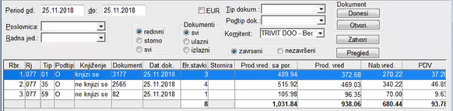

Fig. 23.1 – Maxi R filter result screen: “Tip 59” is the document for Quantity mismatches. Some documents have ZPR mentioned in place of 59 as shown in Fig 23.2

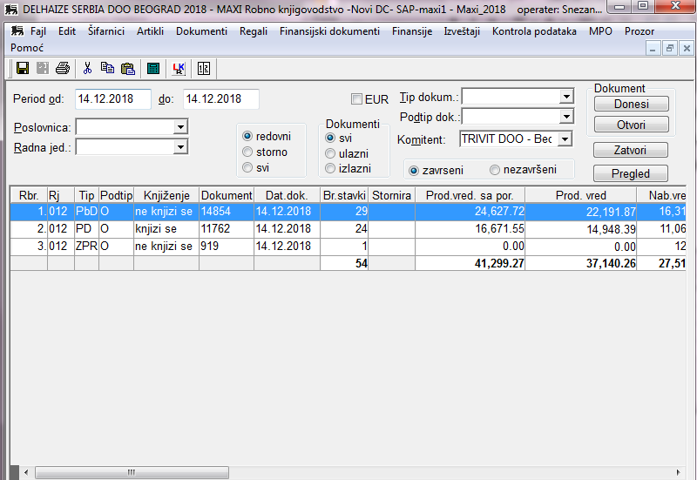

Fig. 23.2 – Maxi R filter result screen: with “ZPR” mentioned in place of 59 for quantity mismatch document

1. Open the Mismatch document by double clicking on the document

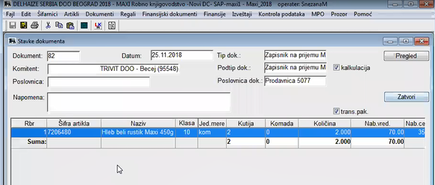

Fig. 24.1 –Quantity mismatch document: showing the details of the quantity mismatch

1. Compare the details in this Maxi R screen with SAP screen on step 15
2. Raise the query with the Store or Vendor based on the findings

# Scheduling of Activities

The frequency of “Mismatch management for EDI” is a daily activity and will be done throughout the day. User starts working thee assigned vendor and moves to the next vendor based on the amount of work and submits their invoices or raises queries. The whole activity takes approximately 1.5 hours every day for seven resources in the team

# User rights and access

Description of Roles/Users for each process and Rights given to the user thru AD's Webduam tool

Similar to below screenshot –AD team to provide the screen shots

